**The Art of War (孫子兵法)**

**Literature Circles**

Copies of *The Art of War*, typically written on sets of sewn-together bamboo slats, ended up in the hands of politicians, military leaders and scholars across China over time. From there, translated copies of “Sun Tzu’s” work found their way to Korea and Japan, which made it one of the most influential texts in Asian History. Japanese samurai, for example, studied it closely. It was translated into French in the 1770s, which is when it made it into the Western World *(Historians say that the French emperor Napoleon was the first Western leader to follow its teachings).* It was translated into English in 1905, and now you will read portions of it!

Learning Objective: To understand the impact of *The Art of War* on the world, and how the book relates to the time period and culture that created it.

**Activity (prepare for tomorrow)**: Read selections from *The Art of War*, and then participate in a small group literary discussion based on those excerpts).

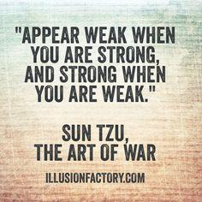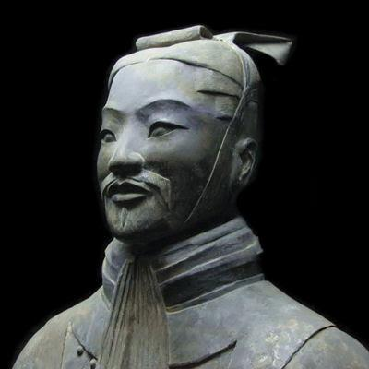

You have been assigned one of the roles below in order to facilitate the discussion surrounding the excerpts. *Of course, depending on the number of people in each group, there may be more than one of each role in a group.* **YOU MUST READ THE ENTIRE EXCERPT.**

1. Discussion Director: You will develop a list of four high-order thinking questions that your group might want to discuss about your excerpt***(use the depth of knowledge chart on the last page of this PDF to help you develop those questions****)*. These should facilitate discussion and not be “yes or no” or “simple to answer” questions. You should focus on some of the AP World course themes *(****found on the page slide of this word doc****)*.
2. Connector/Researcher: You will find some information or material that helps your group to better understand the excerpt and its importance. This is NOT a research paper! Just investigate something that really interests you – something that struck you as puzzling or curious while you were reading. You will find connections not only between what you read in the excerpt and your homework assignments during this time period, but also some connections to either China’s past or present. YOU WILL NEED TO DO SOME RESEARCH. You are welcome to discuss any other connections that strike you as well, even personal connections. Please write up a brief summary of your findings in a word doc.
3. Literary Luminary: You will locate a few special sections (4) or quotations in the text for your group to discuss. The idea is to help your peers dig into some interesting, powerful, puzzling, or important sections of the reading and think about them more carefully. As you decide which passages are worth going back to, be sure to write out *why* you picked each section. Note them by section/title (roman numeral/chapter title), and number.
4. Scribe: You won’t have any extra work tonight; your extra work comes tomorrow when you will write a 3-4 sentence insight for what you and your group discussed.
5. Tomorrow, you will get into your groups and have an in-depth discussion concerning the excerpt. It will be led by the **discussion director**, but everyone will be expected to participate through the lens of their roles and more.
6. You will create a shared word doc for your table and submit all work on Google Classroom. 1.The four high order discussion questions, The researcher’s summary, the literary luminaries quotations and the scribes insight.
7. After the original small group literary circle, we will come back as a class to discuss how the source represents the Warring States Period, your personal opinions, its historical importance, if you think it’s important for military personnel to read it, important connections, etc.

**The Art of War**   
By Sun Tzu

Translated by Lionel Giles

**I. Laying Plans**   
  
**1.** Sun Tzu said: The art of war is of vital importance to the State.   
  
**2.** It is a matter of life and death, a road either to safety or to ruin. Hence it is a subject of inquiry which can on no account be neglected.   
  
**17.** According as circumstances are favorable, one should modify one's plans.   
  
**18.** All warfare is based on deception.   
  
**19.** Hence, when able to attack, we must seem unable; when using our forces, we must seem inactive; when we are near, we must make the enemy believe we are far away; when far away, we must make him believe we are near.   
  
**20.** Hold out baits to entice the enemy. Feign disorder, and crush him.   
  
**21.** If he is secure at all points, be prepared for him. If he is in superior strength, evade him.   
  
**22.** If your opponent is of choleric temper, seek to irritate him. Pretend to be weak, that he may grow arrogant.   
  
**23.** If he is taking his ease, give him no rest. If his forces are united, separate them.   
  
**24.** Attack him where he is unprepared, appear where you are not expected.   
  
**25.** These military devices, leading to victory, must not be divulged beforehand.   
  
  
**II. Waging War**   
  
**6.** There is no instance of a country having benefited from prolonged warfare.   
  
**11.** On the other hand, the proximity of an army causes prices to go up; and high prices cause the people's substance to be drained away.   
  
**12.** When their substance is drained away, the peasantry will be afflicted by heavy exactions.   
  
**13,14.** With this loss of substance and exhaustion of strength, the homes of the people will be stripped bare, and three-tenths of their income will be dissipated; while government expenses for broken chariots, worn-out horses, breastplates and helmets, bows and arrows, spears and shields, protective mantles, draught-oxen and heavy wagons, will amount to four-tenths of its total revenue.   
  
**15.** Hence a wise general makes a point of foraging on the enemy. One cartload of the enemy's provisions is equivalent to twenty of one's own.

**16.** Now in order to kill the enemy, our men must be roused to anger; that there may be advantage from defeating the enemy, they must have their rewards.   
  
**17.** … The captured soldiers should be kindly treated and kept.   
  
  
**III. Attack by Stratagem**   
  
**1.** Sun Tzu said: In the practical art of war, the best thing of all is to take the enemy's country whole and intact; to shatter and destroy it is not so good. So, too, it is better to recapture an army entire than to destroy it, to capture a regiment, a detachment or a company entire than to destroy them.   
  
**6.** Therefore the skillful leader subdues the enemy's troops without any fighting; he captures their cities without laying siege to them; he overthrows their kingdom without lengthy operations in the field.   
  
  
**18.** Hence the saying: If you know the enemy and know yourself, you need not fear the result of a hundred battles. If you know yourself but not the enemy, for every victory gained you will also suffer a defeat. If you know neither the enemy nor yourself, you will succumb in every battle.

**IV. Tactical Dispositions**   
  
**14.** Hence the skillful fighter puts himself into a position which makes defeat impossible, and does not miss the moment for defeating the enemy.   
  
**15.** Thus it is that in war the victorious strategist only seeks battle after the victory has been won, whereas he who is destined to defeat first fights and afterwards looks for victory.   
  
**16.** The consummate leader cultivates the moral law, and strictly adheres to method and discipline; thus it is in his power to control success.   
  
**V. Energy**   
  
**1.** Sun Tzu said: The control of a large force is the same principle as the control of a few men: it is merely a question of dividing up their numbers.   
  
**5.** In all fighting, the direct method may be used for joining battle, but indirect methods will be needed in order to secure victory.   
  
**10.** In battle, there are not more than two methods of attack--the direct and the indirect; yet these two in combination give rise to an endless series of maneuvers.   
  
**13.** The quality of decision is like the well-timed swoop of a falcon which enables it to strike and destroy its victim.   
  
**15.** Energy may be likened to the bending of a crossbow; decision, to the releasing of a trigger.   
  
**21.** The clever combatant looks to the effect of combined energy, and does not require too much from individuals. Hence his ability to pick out the right men and utilize combined energy.

**VI. Weak Points and Strong**   
  
**1.** Sun Tzu said: Whoever is first in the field and awaits the coming of the enemy, will be fresh for the fight; whoever is second in the field and has to hasten to battle will arrive exhausted.   
  
**2.** Therefore the clever combatant imposes his will on the enemy, but does not allow the enemy's will to be imposed on him.   
  
**7.** You can be sure of succeeding in your attacks if you only attack places which are undefended. You can ensure the safety of your defense if you only hold positions that cannot be attacked.   
  
**16.** The spot where we intend to fight must not be made known; for then the enemy will have to prepare against a possible attack at several different points; and his forces being thus distributed in many directions, the numbers we shall have to face at any given point will be proportionately few.   
  
**24.** Carefully compare the opposing army with your own, so that you may know where strength is superabundant and where it is deficient.   
  
**28.** Do not repeat the tactics which have gained you one victory, but let your methods be regulated by the infinite variety of circumstances.   
  
**VII. Maneuvering**   
  
**5.** Maneuvering with an army is advantageous; with an undisciplined multitude, most dangerous.   
  
**11.** We may take it then that an army without its baggage-train is lost; without provisions it is lost; without bases of supply it is lost.   
  
**12.** We cannot enter into alliances until we are acquainted with the designs of our neighbors.   
  
**13.** We are not fit to lead an army on the march unless we are familiar with the face of the country--its mountains and forests, its pitfalls and precipices, its marshes and swamps.   
  
**14.** We shall be unable to turn natural advantage to account unless we make use of local guides.   
  
**19.** Let your plans be dark and impenetrable as night, and when you move, fall like a thunderbolt.   
  
**20.** When you plunder a countryside, let the spoil be divided amongst your men; when you capture new territory, cut it up into allotments for the benefit of the soldiery.   
  
**28.** Now a soldier's spirit is keenest in the morning; by noonday it has begun to flag; and in the evening, his mind is bent only on returning to camp.   
  
**31.** To be near the goal while the enemy is still far from it, to wait at ease while the enemy is toiling and struggling, to be well-fed while the enemy is famished:--this is the art of husbanding one's strength.   
  
**32.** To refrain from intercepting an enemy whose banners are in perfect order, to refrain from attacking an army drawn up in calm and confident array:--this is the art of studying circumstances.   
  
**36.** When you surround an army, leave an outlet free. Do not press a desperate foe too hard.   
  
**IX. The Army on the March**   
  
**1.** Sun Tzu said: We come now to the question of encamping the army, and observing signs of the enemy. Pass quickly over mountains, and keep in the neighborhood of valleys.   
  
**2.** Camp in high places, facing the sun. Do not climb heights in order to fight. So much for mountain warfare.   
  
**3.** After crossing a river, you should get far away from it.   
  
**11.** All armies prefer high ground to low and sunny places to dark.   
  
**12.** If you are careful of your men, and camp on hard ground, the army will be free from disease of every kind, and this will spell victory.   
  
**17.** If in the neighborhood of your camp there should be any hilly country, ponds surrounded by aquatic grass, hollow basins filled with reeds, or woods with thick undergrowth, they must be carefully routed out and searched; for these are places where men in ambush or insidious spies are likely to be lurking.   
  
**35.** The sight of men whispering together in small knots or speaking in subdued tones points to disaffection amongst the rank and file.   
  
**43.** Therefore soldiers must be treated in the first instance with humanity, but kept under control by means of iron discipline. This is a certain road to victory.

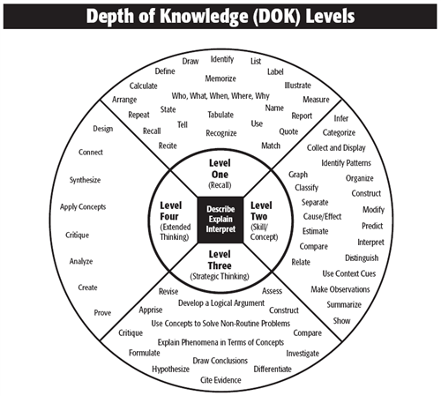  
**XIII. The Use of Spies**   
  
**6.** Knowledge of the enemy's dispositions can only be obtained from other men.   
  
**14.** Hence it is that which none in the whole army are more intimate relations to be maintained than with spies. None should be more liberally rewarded. In no other business should greater secrecy be preserved.   
  
**18.** Be subtle! be subtle! and use your spies for every kind of business.   
  
**27.** Hence it is only the enlightened ruler and the wise general who will use the highest intelligence of the army for purposes of spying and thereby they achieve great results. Spies are a most important element in water, because on them depends an army's ability to move.

**DEPT OF KNOWLEDGE QUESTION CHART/COURSE THEMES *for the Discussion Director***

**AP Course Themes**

#### ****Course Themes:****

1. Interaction Between Humans and the Environment

2. Development and Interaction of Cultures

3. State Building, Expansion, and Conflict

4. Creation, Expansion, and Interaction of Economic Systems

5. Development and Transformation of Social Structures